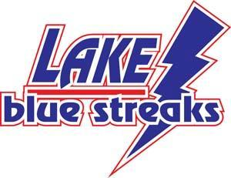
Please Sign and Return

Lake Local School District
Parent-School Compact
2021-2022

The purpose of the Parent-School Compact, found in section 1118 of Public Law 130-382, is to build and foster the development of a parent-school partnership to help all children achieve the State’s high standards. Responsibility for improved student achievement will be shared by parents, the child, and teachers.

It is the school’s responsibility to provide high-quality curriculum and instruction in a supportive and effective environment that enables the children to meet the State’s student performance standards. Each parent is responsible for supporting their child’s learning, such as monitoring attendance, homework completion, and television watching; volunteering in their child’s classroom, and participating, as appropriate, in decisions relating to the education of their children and positive use of extracurricular time.

This parent-school compact is in effect during the 2021-2022 school year.
Parent/Guardian Responsibilities:
We, as parents, will support our children’s learning in the following ways:
- Make sure my child gets enough sleep each night
- Encourage my child to complete his/her homework
- Monitor amount of television my child watches
- Volunteering in my child’s classroom
- Attend Open House and Parent/Teacher Conferences
- Spend at least 15 minutes a day reading to/with my child
- Staying informed about my child’s education and communicating with the school by promptly reading all notices from the school or the school district either received by my child or by mail and responding, as appropriate.
- Other: ______________________________________________________________________________

Student Responsibilities:
I will share the responsibility to improve my academic achievement and achieve the state’s high standards:
- Do my homework every day and ask for help when I need it
- Do my classwork on time
- Give my parents or guardian all notices and information received by me from my school every day
- Be responsible for my own behavior
- Pay attention and do my work
- Other: ______________________________________________________________________________

Title I Teacher:
I understand the importance of the school experience to every student and my role as a teacher and role
model. Therefore, I agree to carry out the following responsibilities to the best of my ability:
- Provide a high-quality curriculum that enables your child to meet the state’s high standards
- Notify parents of changes affecting attendance, achievement, grades, or behavior
- Regularly communicate with you regarding your child’s progress
- Participate in conferences
- Encourage your child

Title I Teacher ____________________________________ Date ________________________

Parent ___________________________________________ Date ________________________
Student __________________________________________ Date ________________________

